Practical No: 03

VIII. Resources required (Additional)
- If any web reference is required.

Resources required (Actual)
  - https://docs.microsoft.com/en-us/dotnet/visual-basic/programming-guide/language-features
/operators-and-expressions/arithmetic-operators
  - https://docs.microsoft.com/en-us/dotnet/api/system.windows.forms.messagebox?View= netframework-4.7.2

Program Code:
Write a program using MessageBox and Arithmetic Expressions –

Module Module1
Dim i, j, r As Integer

Sub Main()
Console.WriteLine("Enter First Value=") i = Console.ReadLine()
Console.WriteLine("Enter Second Value=") j = Console.ReadLine() Console.ReadLine()
MsgBox("Addition =" & (i + j)) MsgBox("Substraction =" & (i - j)) MsgBox("Multiplication =" & (i * j)) MsgBox("Division =" & (i / j))
End Sub End Module

Results (Output of the Program) Enter First Value=
10

Enter Second Value= 5
---------------------------

MessageBoxPractical3
---------------------------

Addition =15
--------------------------- OK

---------------------------

- Practical Related Questions

Write the difference between MessageBox() and ErrorProvider Control –
- Displays a message window, also known as a dialog box, which presents a message to the user. It is a modal window, blocking other actions in the application until the user closes it. A MessageBox can contain text, buttons, and symbols that inform and instruct the user.
- Sets the error description string for the specified control. When an error occurs for the value in associated control, then a small red color icon is displayed and when we hover the mouse on icon it displays an error message.

Describe any four types of MessageBox() Window –
In Visual Basic, MessageBox has Show() method and it is overloaded to create various types of MessgeBoxes and various programming situations –

It has prototype –
DialogResult Show(String text, String caption, MessageBoxButtons buttons, MessageBoxIcon icon, MessageBoxDefaultButton defaultButton)
This method is static and doesn’t required and object reference. The parameters and return values are explained below –

Parameters
    - text As String - The text to display in the message box.
    - caption As String - The text to display in the title bar of the message box.
    - buttons As MessageBoxButtons - One of the MessageBoxButtons values that specifies which buttons to display in the message box.
    - icon As MessageBoxIcon - One of the MessageBoxIcon values that specifies which icon to display in the message box.
    - defaultButton As MessageBoxDefaultButton - One of the MessageBoxDefaultButton values that specifies the default button for the message box.

Returns
DialogResult - One of the DialogResult values.

Exercise
  - Implement the program to generate result of any arithmetic operation using MessageBox().
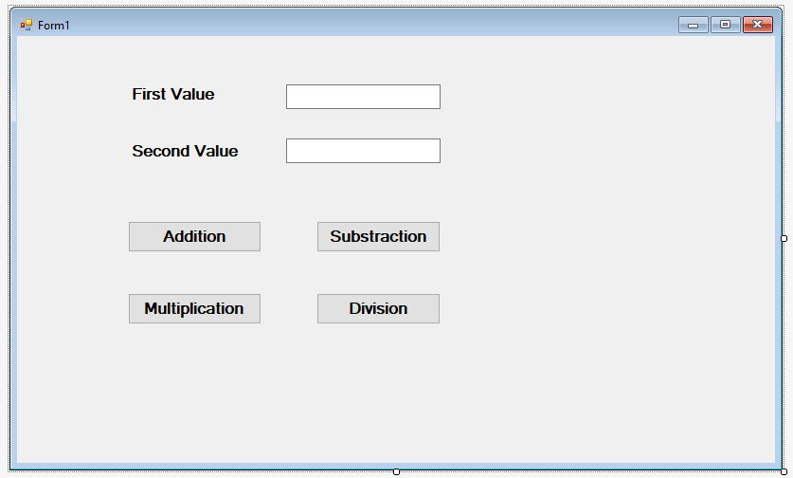
➢
Public Class Form1 Dim n As Integer
Private Sub Button1_Click(sender As Object, e As EventArgs) Handles Button1.Click n = Val(TextBox1.Text) + Val(TextBox2.Text)
MsgBox("Addition=" & n) End Sub
Private Sub Button2_Click(sender As Object, e As EventArgs) Handles Button2.Click n = Val(TextBox1.Text) - Val(TextBox2.Text)
MsgBox("Substraction=" & n) End Sub
Private Sub Button3_Click(sender As Object, e As EventArgs) Handles Button3.Click n = Val(TextBox1.Text) * Val(TextBox2.Text)
MsgBox("Multiplication=" & n) End Sub
Private Sub Button4_Click(sender As Object, e As EventArgs) Handles Button4.Click n = Val(TextBox1.Text) / Val(TextBox2.Text)
MsgBox("Division=" & n) End Sub
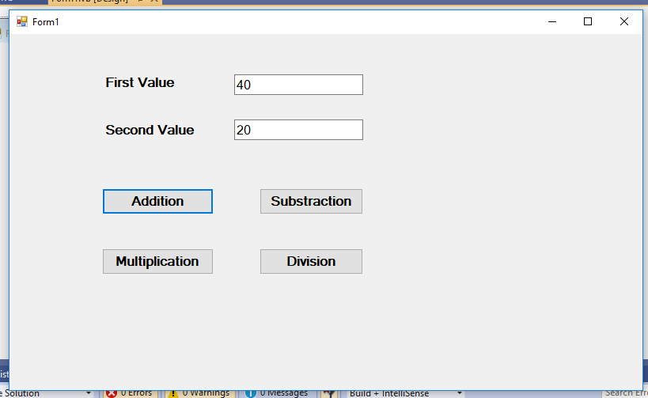
End Class
-Arithmetic Operation using msgbox

Addition=60

OK

Write a program using InputBox(), MessageBox() & perform various Arithmetic expressions.
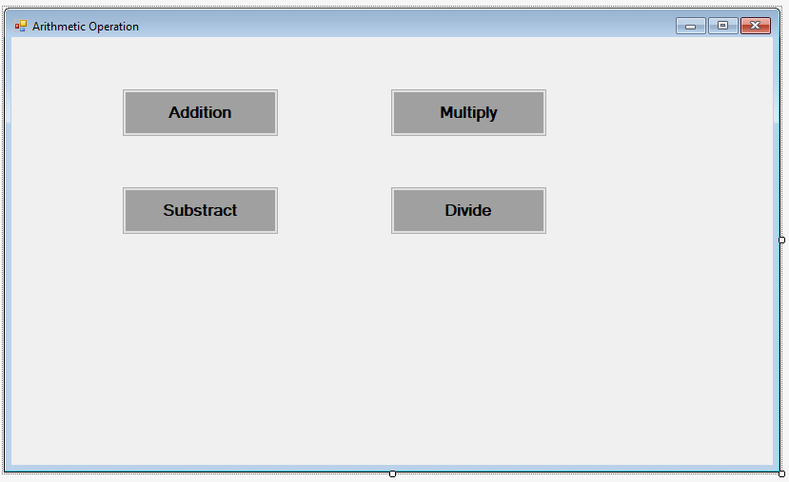
➢
Public Class Form1 Dim i, j, r As Integer

Private Sub Button2_Click(sender As Object, e As EventArgs) Handles Button2.Click i = InputBox("Enter First Value")
j = InputBox("Enter Second Value") r = Val(i) - Val(j) MsgBox("Substract = " & r)
End Sub

Private Sub Button4_Click(sender As Object, e As EventArgs) Handles Button4.Click i = InputBox("Enter First Value")
j = InputBox("Enter Second Value") r = Val(i) / Val(j)
MsgBox("Divide = " & r) End Sub

Private Sub Button3_Click(sender As Object, e As EventArgs) Handles Button3.Click i = InputBox("Enter First Value")
j = InputBox("Enter Second Value") r = Val(i) * Val(j) MsgBox("Multiply = " & r)
End Sub

Private Sub Button1_Click(sender As Object, e As EventArgs) Handles Button1.Click i = InputBox("Enter First Value")
j = InputBox("Enter Second Value") r = Val(i) + Val(j) MsgBox("Addition = " & r)

End Sub End Class

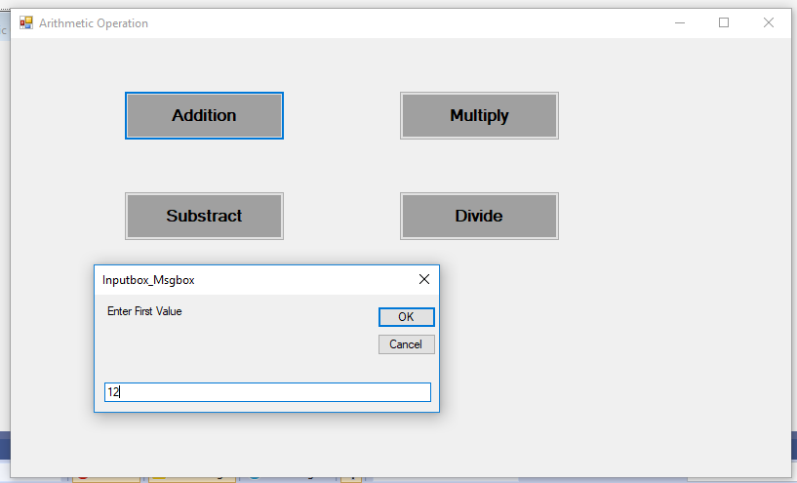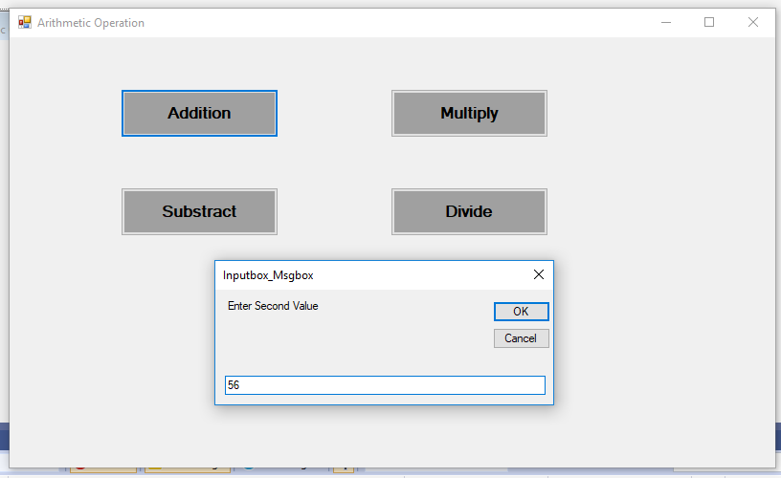Output:

Inputbox_Msgbox

Addition = 68

OK

